**1) Find the transpose of a given matrix using list comprehension.**

**2) Write a Python program to find the repeated items of a tuple.**

**Code:**

**t1=eval(input())**

**dict1={}**

**for i in range(len(t1)):**

**if(t1.count(t1[i])>1):**

**dict1[t1[i]]=t1.count(t1[i])**

**print(list(dict1.keys()))**

**print("Name-Aryaman Kumar,registration no-22BRS1184")**

**Output:**

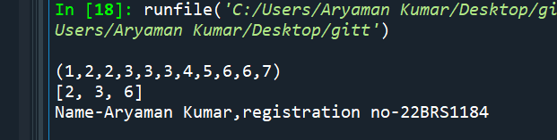

**3) Given a Python list. Turn every item of a list into its square**

**input: aList = [1, 2, 3, 4, 5, 6, 7]**

**output: [1, 4, 9, 16, 25, 36, 49]**

**Code:**

**n=int(input())**

**alist=[]**

**list2=[]**

**for i in range(n):**

**a=int(input())**

**alist.append(a)**

**list2.append(alist[i]**2)**

**print(list2)**

**print("Name-Aryaman Kumar,registration no-22BRS1184")**

**Output:**

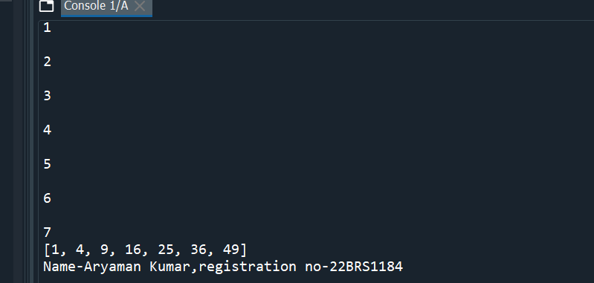

**4) Write a program that reads a string and prints the letters in decreasing order of frequency.**

**5) Write a program to perform row wise sum and column wise sum of a matrix and store the results in two separate matrices namely row_sum and column_sum.**

**6) Write a program to arrange all the elements in the matrix in descending order.**

**7) Write a program to check whether two matrices are identical.**

**8) Write a program to get a sentence as input from the user. Using dictionary draw the histogram of characters and histogram of words in the given sentence.**

**9) Write a Python script to generate and print a dictionary that contains a number (between 1 and n) in the form (x, x*x). Sample Dictionary ( n = 5) : Expected Output: {1: 1, 2: 4, 3: 9, 4: 16, 5: 25}.**

**Code:**

**dict1={}**

**n=int(input())**

**for i in range(1,n):**

**dict1[i]=i*i**

**print(dict1)**

**print("Name-Aryaman Kumar,registration no-22BRS1184")**

**Output:**

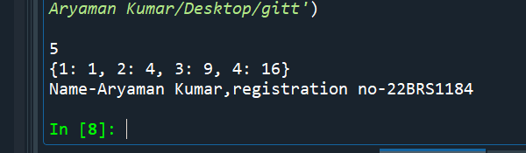

**10)Create a dictionary with the names as keys and marks as values by user input.**

**Write a Python program to sum all the marks in a dictionary and display it.**

**Code:**

**dict1={}**

**n=int(input("Enter number of students"))**

**for i in range(n):**

**names=input()**

**marks=int(input())**

**dict1[names]=marks**

**print("Sum of marks",sum(list(dict1.values())))**

**print("Name-Aryaman Kumar,registration no-22BRS1184")**

**Output:**

